Relieving The Pressures Of ‘Flushable Wipe' Clogs In Public Sewers
Source: Duperon
The adage about the three most important factors in real estate value — location, location, location — carries a certain degree of truth for wastewater collection systems as well. How close to the source of problematic clogging materials a debris handling solution is installed can be just as important as how efficiently that solution neutralizes them — an especially critical response to increased ‘flushable wipes’ use resulting from the COVID-19 pandemic. Here are several ways to evaluate each of those variables and choose the best option.
Minimize Risk By Maximizing Resilience
With the recent proliferation of flushable (but not degradable) wipes, wastewater collection systems have seen a rise in the incidence and expense of dealing with problems they can create. Those problems can also be compounded by congealed fats, oils, and grease (FOG) and by debris introduced through inflow and infiltration (I&I).
Wastewater collection systems operators, front-line managers, and consulting engineers faced with disruptive clogs appreciate the value of removing the bulk of problematic debris closest to its source of introduction. Early intervention keeps upstream laterals free flowing and minimizes the potential risk of blockages and other negative impacts in downstream lift stations, pumps, and other infrastructure. It also minimizes the likelihood of disruptive, hazardous, or after-hours emergency maintenance calls and all the aggravating factors that accompany them.
But until the introduction of manhole-mounted debris handling technology that could easily be installed closest to the most likely sources of flushable wipes, rags, and other harder debris — e.g., hospitals, nursing facilities, daycare centers, prisons, truck stops, etc. — most alternatives left decision-makers stuck between a rag and a hard place.
Pros And Cons Of A Progression Of Risk Reduction Approaches
Consider the differences in these four potential approaches, their relative abilities to minimize clog problems, and their relative impacts on the costs of implementation and maintenance, including potential impacts on wastewater treatment plant (WWTP) efficiency:
- Manual Cleanouts. This original response to pump clogs is no more efficient, economical, easier, or safer than it was before flushable wipes. The dirty and thankless task can occur at any hour of the day or night, expose workers to dangerous debris (such as needles), and force them into hazardous atmospheres that require special worker protection equipment. At best, it is a repetitive, short-term reaction to problems at each specific location, not a preventive step. Worst-case scenario, this approach is accompanied by downtime, costly (and long lead time) replacement parts, and frequent trips to alleviate the issue. This leaves the entire collection system unpredictably vulnerable.
- Grinders. While grinders have shown some success in reducing pump clogs at their installed location, they can be maintenance intensive and still not remove downstream problems entirely. Sharpening grinder blades or rebuilding the unit entirely adds expense and time offline. Furthermore, grinders simply shred materials into smaller pieces that need to be dealt with later in the collection system, especially if rag and wipe strands re-weave themselves into clog-inducing ropes or balls downstream of the grinder mechanism. Even smaller pieces of debris that do not break down in the process can lead to WWTP problems with clarification, aeration, and, more frequently, expensive digester cleanouts. By not removing the debris, grinders pose downstream system risk.
- Vertical Screw Screens. Vertical screw screens installed at larger collection points — closer to the sewer mains and trunk sewers than individual laterals — can protect downstream infrastructure from flushable wipes but not upstream lift pumps. Units limited to fewer, larger locations because of their size or cost can be a case of ‘too little, too late’ if upstream pumps in smaller sewer lines still demand frequent maintenance related to localized debris issues. Also, designs that demand frequent maintenance visits due to mechanical jamming or brush maintenance can escalate the total cost of ownership and operation.
- Source-Point Solutions. Newer screen and dual auger units designed to retrofit easily into existing manholes closest to known sources of wipes or debris offer the best of both worlds in terms of removing the bulk of problematic debris in one piece and earlier in the collection system (Figure 1). This precludes the formation of twisted strands or balls farther downstream and minimizes the need for WWTP basin cleanouts of chopped wipe fragments. Designs that eliminate debris-catching brushes and can accumulate dried debris for weeks before required pickup can also minimize both planned and unplanned maintenance activities.
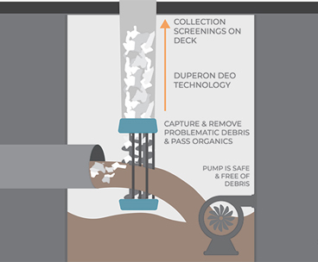
Graphic courtesy of Duperon
Figure 1. The concept of this Dual Auger System designed to capture whole wipes and other debris from troublesome small lateral lines offers an affordable solution that minimizes costs and headaches associated with frequently clogged pumps or maintenance intensive grinders.
Compare Details That Matter Most
Here are some key attributes to consider when installing new sewer infrastructure or trying to remedy pinpointed problems in existing infrastructure:
- Equipment Cost/Performance. Don’t compare costs on debris handling systems only. Be sure to evaluate the lowest total lifecycle cost for maintenance and debris handling associated with each choice. For example, clearing troublesome upstream sewer laterals can enable the specification of more efficient pump designs farther downstream thanks to reduced risk of clogging or damage.
- Civil Engineering Costs. Debris handling solutions designed to fit easily into existing manhole infrastructure can save significant time and expense as compared to custom engineering new, larger, or more complex structures downstream.
- Mechanical Maintenance. Debris handling mechanisms that rely on brushes to clean screens or bars are often subject to disruptions for replacing the brushes. Once the brushes wear, the screening system becomes less effective — causing blockages, overflows, and maintenance. Brushless designs with counter-rotating augers minimize opportunities for such problems (Figure 2).
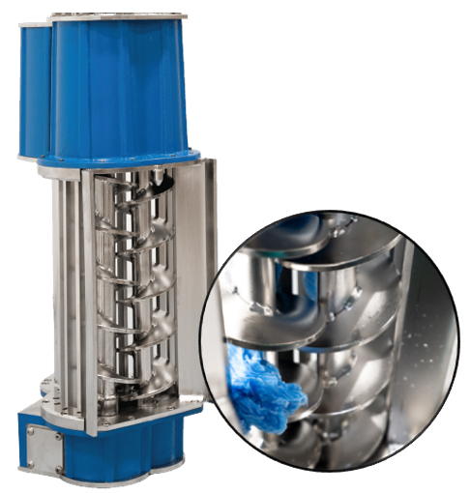
Photos courtesy of Duperon
Figure 2. The 0.71” bar spacing and dual auger construction of this compact unit capture and remove a variety of debris — whole wipes, rags, and other large solids. Captured debris is dewatered as it is pushed up a discharge extension chute to ground level for collection and removal. The brushless, self clearing design eliminates the need for cleaning maintenance on the lower unit.
- Labor Scheduling. Solutions that preclude opportunities for blockages in wastewater infrastructure reduce the likelihood of emergency maintenance for dirty and potentially dangerous cleanup or repair work. This offers greater flexibility to attend to more critical infrastructure needs, reducing overall pressures on resource strapped utilities.
- Debris Collection. Systems that collect, dewater, and store captured debris within an enclosed chute can extend removal requirements to a scheduled biweekly (or longer) basis, minimizing employee effort and improving safety without risking public exposure to debris or odor (Figure 3).
- Downstream Impacts. Finally, look for any downstream impacts that can add to the total cost of operation. That can include rope formation from long strands of shredded wipes that escape downstream and costly cleanouts in clarifiers, digesters, and other treatment basins to remove shredded wipes and rags. Even effluent water quality can be impacted.
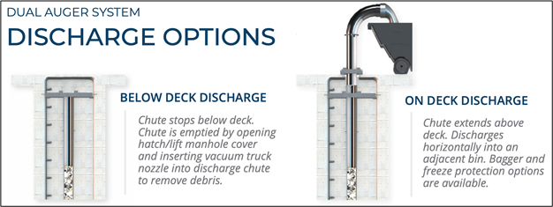
Graphics courtesy of Duperon
Figure 3. The ability to store weeks of captured debris without impacting ongoing operations offers maximum labor scheduling convenience. The ability to access stored debris above or below ground level offers flexibility in cleanout options to suit utility collection equipment and practices.
One Design Satisfies Many Situations
It is not often that one mechanical solution fits multiple applications, but this Dual Auger System is designed as an easy retrofit in any wet well or manhole application from 17” to 48” wide and up to 30 feet deep, making it a convenient source-point intervention for problematic lines. It screens influent from lateral lines ranging up to 16” in diameter and handles continuous-flow capacities up to 1.5 MGD (1,042 gpm) — with triple that volume for short duration bursts. This makes it a convenient option for addressing problematic debris-laden lines closer to the source of known problems, well upstream from lift/pump stations and major collection arteries. The Dual Auger System is a resilient solution that allows the collection system to work as it was designed, unencumbered by problematic debris and clogs.

